CURRICULAM VITAE
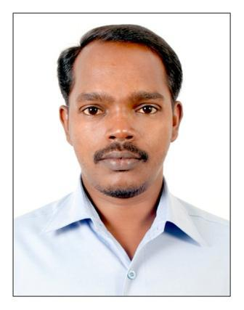
SALIM KUMAR M K
Muttunkalthara House
Maradu P. O
Ernakulam - 682304
Kerala, India
Mob: 9400278373
Email: mk_salim@yahoo.com

PROFILE
A Complete dedication to my noble profession of law, to work in any kind of environment with endurance regardless of hurdles that come my way. I would like to be a part of a core team in a professional organization and believe that my abilities, attitude and dedication would help in adding total value to the organization.

PERSONAL DETAILS
Name : Salim kumar M K
Father’s Name : Kumaran M K
Marital Status : Single
Date of Birth : 22nd March 1974
Sex : Male
Nationality : Indian
Religion : Hindu
Language known : Malayalam, English, Tamil
Phone No. : 9400278373

Oualifications
- SSLC
Government High School Mangayil, Maradu, Ernakulam
Subjects: General
Marks Obtained- 44%
- Pre-Degree
Maharaja’s College Ernakulam
Subjects: Indian History, World History, Political Science
Mark Obtained- 46.86%
- LL.B
Government Law College, Trivandrum
Subjects: Law, History, Sociology, Political Science etc.
Marks Obtained- 52.41%
- LL.M
Department of Law, University of Kerala, Krayavattom, Trivandrum
Specialisation: Constitutional Law, Intellectual Property Law, Administrative Law
Marks Obtained- 62%
Additional Oualifications
- Short term course in M S Office
Experience
- Four years teaching experience in Law.
- One year teaching experience in competitive examination. (General Knowledge)
- Four years experience as Presenter in Gyanvani FM Radio. Various knowledge based programs.
Interested Area
Law, History, Literature, Music

DECLARATION

I hereby declare that the above mentioned information are correct and true to the best of my knowledge and belief.

Place: Trivandrum
Date: 30 Septemberl 2021 Salim kumar m k

